Program Source：
STM32H747XIH6-CD/Code/QSPI_ReadWrite_MIXIC

Function：
QSPI Flash read and write test program, the program remaps the QSPI Flash running address to 0x90000000.

Test Method：
- Select the M4 core configuration as shown below and click the LOAD button to download the M4 core program.
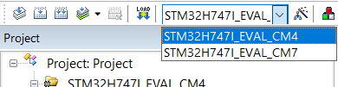
- Select the M7 core configuration as shown below and click the LOAD button to download the M7 core program.
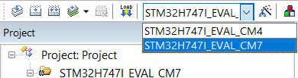
- After the program runs, the data in aTxBuffer is written to the external QSPI Flash. After the data is written, the QSPI Flash space is remapped to the location of 0x90000000 and used as a memory. The program compares the written content through memory comparison. If the data is correct, the LED will light up.

